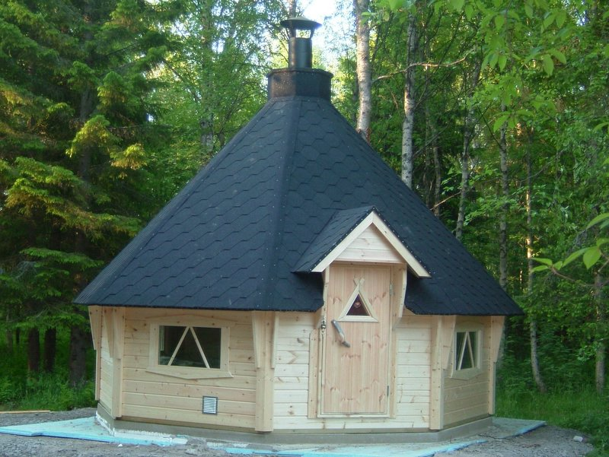 | 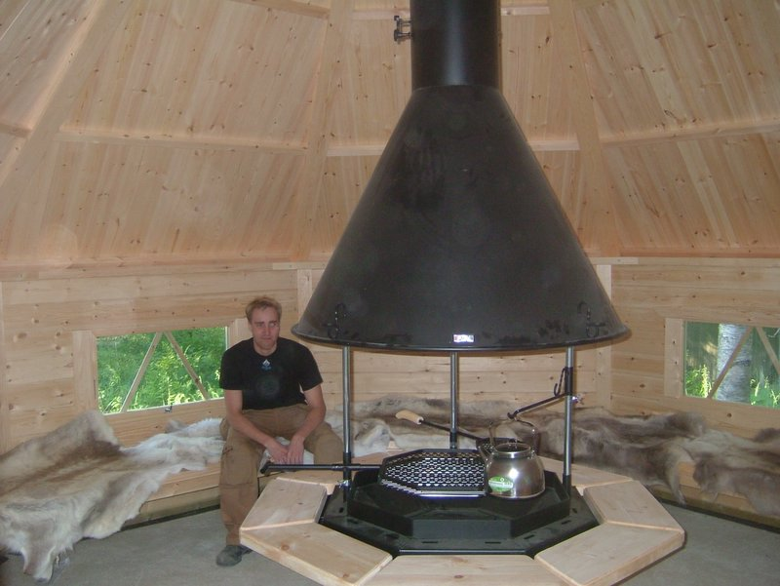
 | 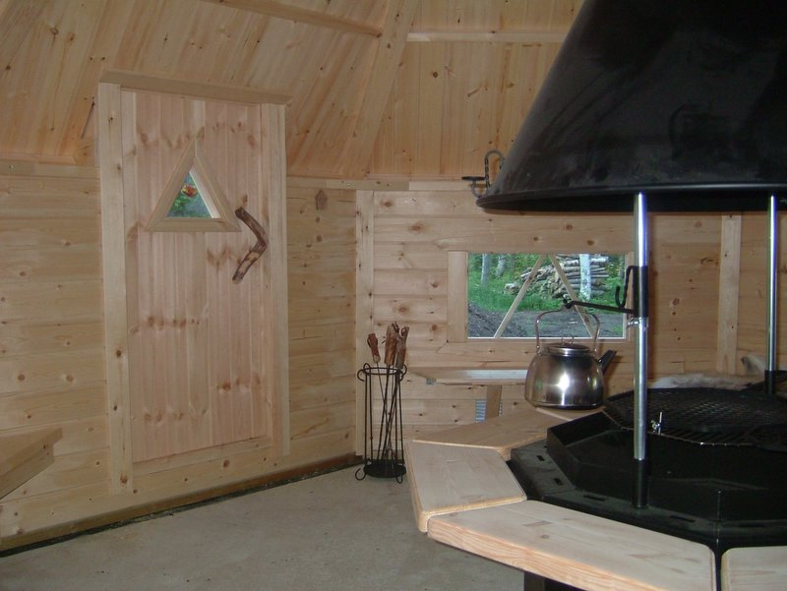
 | 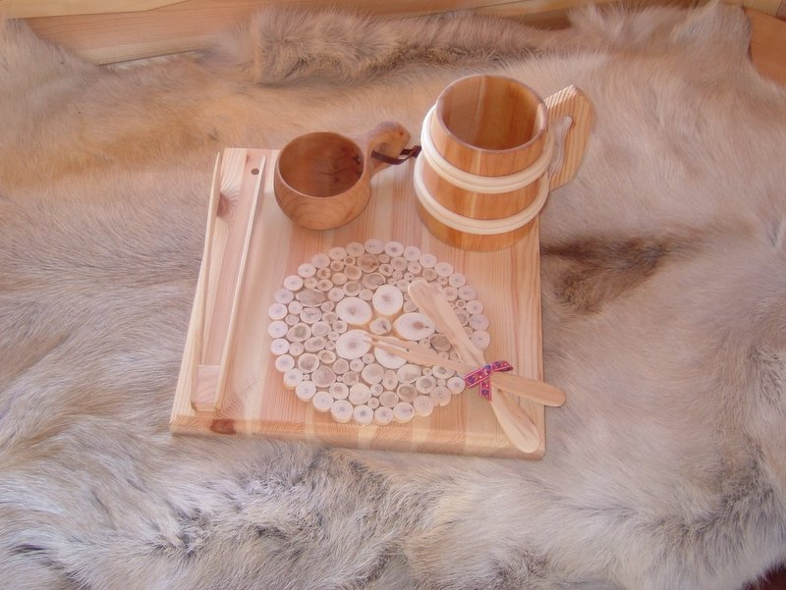
Finnish BBQ Hut 17.2 m² – £9,200
Octagonal – Seating for 30 persons
Roof projection: 0.37 m

Consists of:
Walls: 40 mm double tongue and groove logs from Red Pine.
4.65m x 4.65m
Flooring: Decking that can be removed for cleaning.
Roof: 20 mm tongue and groove roof boards.
Apex height: 4.08m
Doors: 1 door
Windows: 4 windows (1 window opens), double glazed

Included Equipment:
An octagonal grill Toggle tables
A round table around the grill Flower boxes
A grill set Reindeer skins
A brick pan Juniper underlay
A steel kettle

Extras:
Larger windows Call for price
Build Call for price
 | 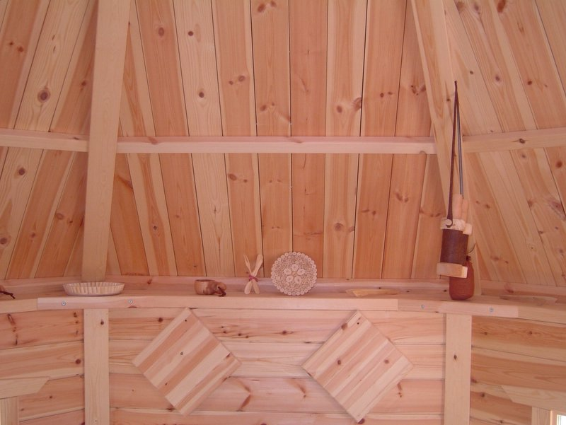
 | 